**Projects Steps**

**Building Data Sources**

* Collect Data
* Connect the Data
* Build Data Model
* Check Data Quality
* Check Data Types
* Understand And Explore Data

**Hierarchy(Department & Job Title) :** Buid a relationship between Dimension that allow users to drill down to finer details

*(Take the job title and drag and drop to the department in left panel)*

**Building Charts**

* Analyse Requirements and & Choosen Chart
* Initial Format Of Sheet
* Create Calculated Fields & Test
* Build Chart
* Format Chart

**User Story - HR Dashboard**

As an HR manager, I want a comprehensive dashboard to analyze human resources data, providing both summary views for high-level insights and detailed employee records for in-depth analysis

**Summary View**

The summary view should be divided into three main sections: Overview, Demographics, and Income Analysis

Overview

The Overview section should provide a snapshot of the overall HR metrics, including:

* **Display the total number of hired employees, active employees, and terminated employees.**

*(I Used BANS its used to Highlight Big data and Number and Measures inside the data in Dashboard)*

**Initial Format Of Sheet**

(Format -> WorkBook -> Trebuchet Ms[Entire Projects])

(Select Colour from Marks pane -> Click on custom colour)  
#03c4a1

#c52a87

#777777

#f5f5f5

(Select #777777 whole projects - Format -> WorkBook -> MoreColours - #777777)

**Background Colour**

Format - > Shadding - > First DarkColour

Use Entire View For all worsksheet

*(Always Hide the titles of worksheets)*

(Right Click on sheet name -> Hide Title)

**Create Calculated Fields & Test**

(what do we want)

We want

**total number of hired employees, active employees, and terminated employees.**

We need to do calculated field there is no direct Tables in dataset so we need to do Calculated field first

Right Click On Left Data Pane -> Create Calculate field - > COUNT([Employee ID])

For Terminate Employee  
  
Logic

Right Click On Left Data Pane -> Create Calculate field - > COUNT([Employee ID])

IF NOT ISNULL([Termdate])THEN [Employee ID] END

COUNT(IF NOT ISNULL([Termdate])THEN [Employee ID] END)

Right Click on Total terminated -> Click on Continuos

For Active Employee  
  
Logic

COUNT(IF ISNULL([Termdate])THEN [Employee ID] END)

Right Click on Total Active -> Click on Continuos

**Visualize the total number of hired and terminated employees over the years.**

Line Chart (It is Used to visualize the trends Overtime)

**Present a breakdown of total employees by department and job titles.**

Bar Chart (It used For Category)

**Index Function(Returns the Index of the Current row)  
Double Click on Rows and type INDEX() - > Right Click - > Conert To Discrete**

**Compare total employees between headquarters (HQ) and branches (New York is the HQ)**

Bar Chart(It used For Comparing The Values)

For Creating the Location(Calculated Field)

**CASE [State]**

**WHEN 'New York' THEN 'HQ'**

**ELSE 'Branch'**

**END**

**Show the distribution of employees by city and state.**

Map( It is best to analyze geopgrphy location)

**Demographics**

**The Demographics section should offer insights into the composition of the workforce, including:**

**Present the gender ratio in the company.**

Pie chart is Best to analyse for this

**Avg(0) PlaceHolder to Plot new Visual.   
 Double Click on column field -> Write Avg(0)**

**Visualize the distribution of employees across age groups and education levels.**

Relationship and Corelation between 2 category so we use Heatmap

**DATEDIF()** - > It is used to returns the difference between two dates in a specified unit(e.q.Year)

**DATEDIFF('year',[Birthdate],TODAY())**

**Age Groups**IF [Age] < 25 THEN '>25'

ELSEIF [Age] >=25 AND [Age] <35 THEN '25-34'

ELSEIF [Age] >=35 AND [Age] <45 THEN '35-44'

ELSEIF [Age] >=45 AND [Age] <55 THEN '45-54'

ELSEIF [Age] >=55 THEN '55+'

END

**Show the total number of employees within each age group.**

We need to do Comparison analayzes in order to compare the values within category so barchart is the best one.

**Show the total number of employees within each education level.**

We need to do Comparison analyzes in order to compare the values within category so bar chart is the best one.

**Present the correlation between employee’s educational backgrounds and their performance ratings.**

We have to show relationship between 2 dimension two categories

So Heatmap is best for this

**Income**

**The income analysis section should focus on salary-related metrics, including:**

* **Compare salaries across different education levels for both genders to identify any discrepancies or patterns.**

We want to see differences between the salary between the different genders so this is not only corelation we are talking as well as about something called Gap Analgises and the best chart is visual Gap Analgises is Barbell Chart, we can easily show the distance between the value as well as we can show Co-relation between two different dimension and categories

* **Present how the age correlate with the salary for employees in each department.**

Scatter plot is amazing inorder to show the corelation measures

**BUILDING HR SUMMARY DASHBOARD**

**Building Dashboards**

Plan the Dashboard

- Dashboard Mockup

-Container Mockup

Create Container Structure

Put All Together

Fixing Colors

Fix Texts

Refine Charts

Fix Spacing (Inner/Outer Spacing)

Fix Tooltips

Add Filters & Legends

Add Logos & Icons

**Plan the Dashboard(MockUp)**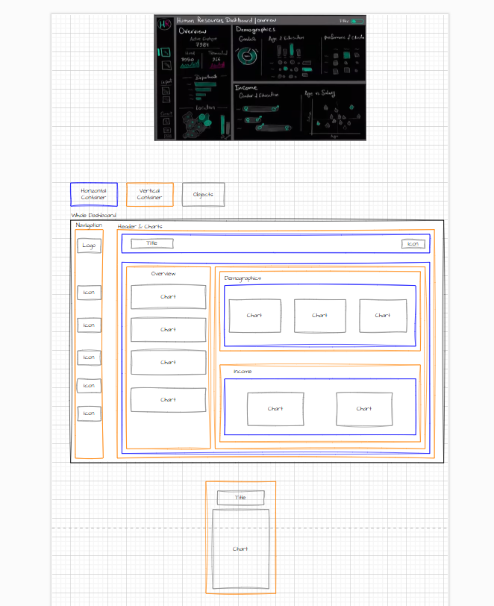

**Building The Dashboard in Tableu**

Dashboard Size  
  
Fixed Size = 1400 * 800

**Contain Structure**

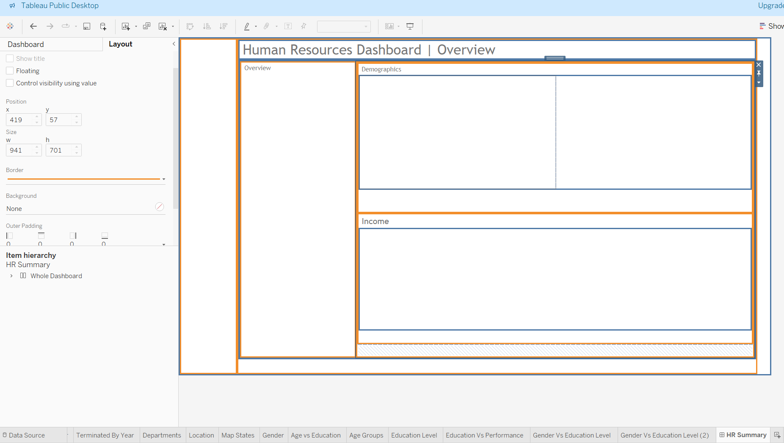

**Put All Together**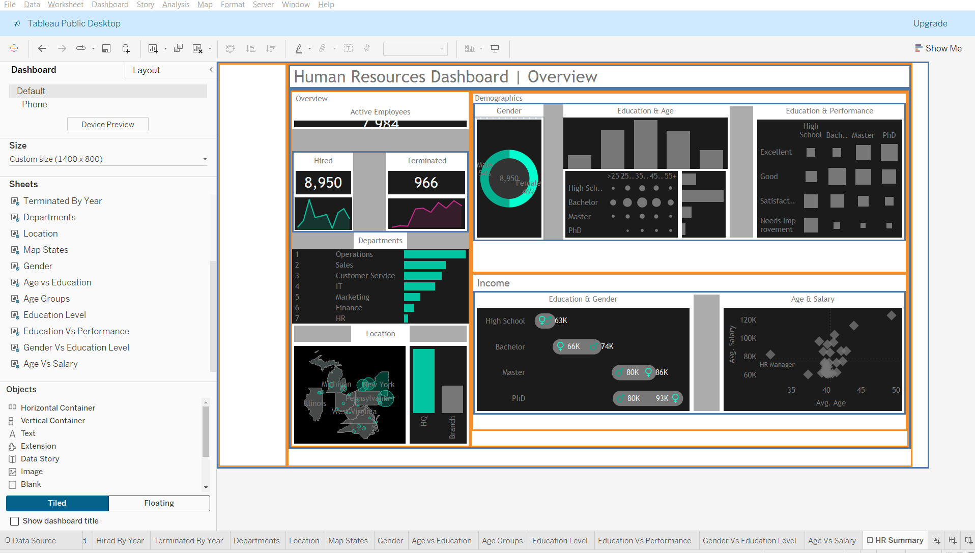

**Fixing Colours.  
